

**FACULTY OF INFORMATION SCIENCE & TECHNOLOGY**

**TCN 2141- COMPUTER NETWORKS**

**Session: Trimester 1, 2019/2020**

**Assignment**

**Lecturer: Dr. Subarmaniam Kannan**

|  |  |
| --- | --- |
| **Members Name** | **Student ID** |
| Lim Zhan Wang | 1161103372 |
| Tay Bee Luan | 1171100212 |

**Physical Topology**

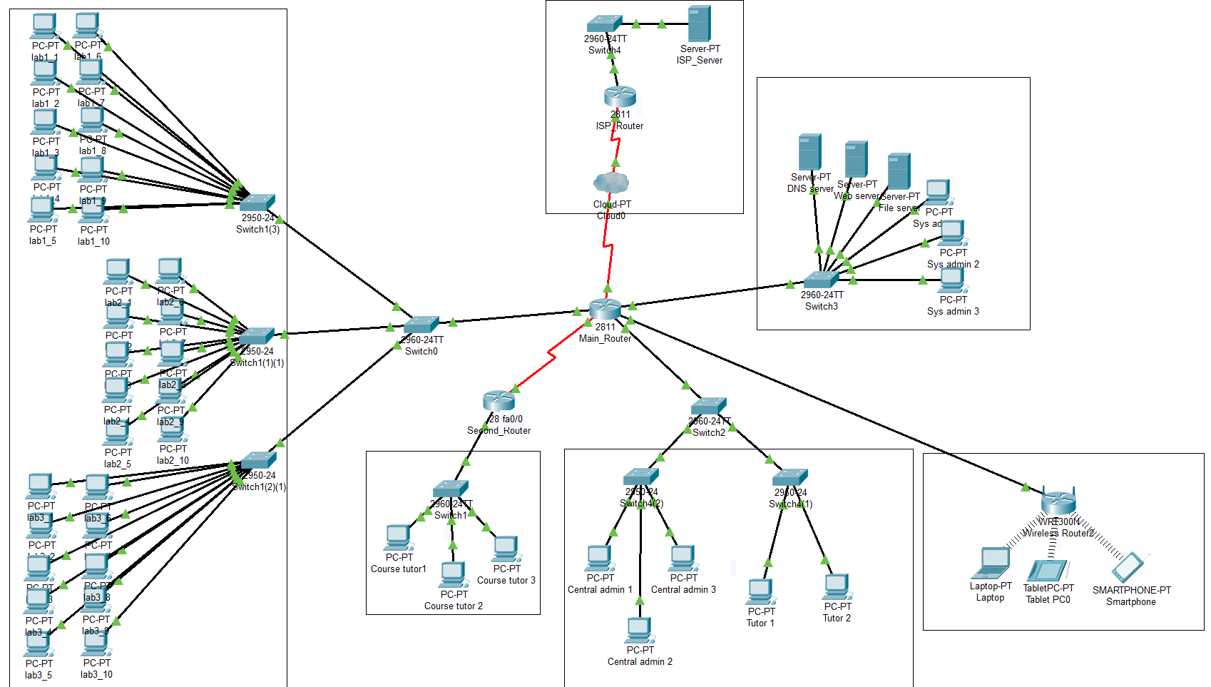

**Logical Topology**

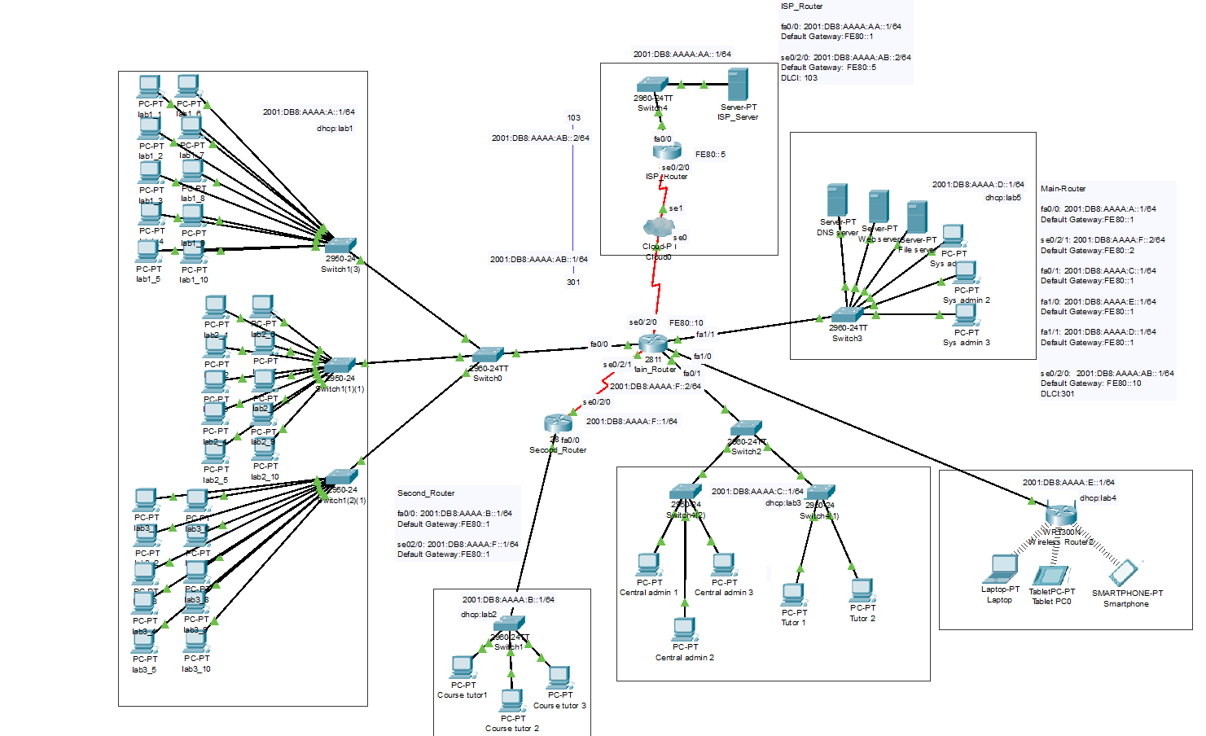

**Logical Design**

|  |  |  |  |  |
| --- | --- | --- | --- | --- |
| **Device** | **Connected From** | **Connected to** | **IPv6 Address** | **IPv6 Gateway** |
| Main_Router | Fa0/0 | Fa0/4 | 2001:DB8:AAAA:A::1/64 | FE80::1 |
| Se0/2/1 | Se0/2/0 | 2001:DB8:AAAA:F::2/64 | FE80::2 |
| Fa0/1 | Fa0/3 | 2001:DB8:AAAA:C::1/64 | FE80::1 |
| Fa1/0 | Ethernet 1 | 2001:DB8:AAAA:E::1/64 | FE80::1 |
| Fa1/1 | Fa0/7 | 2001:DB8:AAAA:D::1/64 | FE80::1 |
| Se0/2/0 | Se0 | 2001:DB8:AAAA:AB::1/64 | FE80::10 |
| Second_Router | Fa0/0 | Fa0/4 | 2001:DB8:AAAA:B::1/64 | FE80::1 |
| Se0/2/0 | Se0/2/1 | 2001:DB8:AAAA:F::1/64 | FE80::1 |
| ISP_Router | Fa0/0 | Fa0/2 | 2001:DB8:AAAA:AA::1/64 | FE80::1 |
| Se0/2/0 | Se1 | 2001:DB8:AAAA:AB::2/64 | FE80::5 |
| DNS Server | Fa0 | Fa0/1 | 2001:DB8:AAAA:D::15/64 | FE80::1 |
| Web Server | Fa0 | Fa0/2 | 2001:DB8:AAAA:D::10/64 | FE80::1 |
| File Server | Fa0 | Fa0/3 | 2001:DB8:AAAA:D::20/64 | FE80::1 |
| ISP Server | Fa0 | Fa0/1 | 2001:DB8:AAAA:AA::10/64 | FE80::1 |
| Sys Admin 1 | Fa0 | Fa0/4 | 2001:DB8:AAAA:D: 260:2FFF:FE13:7C8C | FE80::1 |
| Sys Admin 2 | Fa0 | Fa0/5 | 2001:DB8:AAAA:D: 2D0:97FF:FE0A:135A | FE80::1 |
| Sys Admin 3 | Fa0 | Fa0/6 | 2001:DB8:AAAA:D: 290:2BFF:FE4D:E50A | FE80::1 |
| Central Admin 1 | Fa0 | Fa0/1 | 2001:DB8:AAAA:C: 260:47FF:FE6C:4079 | FE80::1 |
| Central Admin 2 | Fa0 | Fa0/2 | 2001:DB8:AAAA:C: 204:9AFF:FEA8:E5B9 | FE80::1 |
| Central Admin 3 | Fa0 | Fa0/3 | 2001:DB8:AAAA:C: 206:2AFF:FE05:967E | FE80::1 |
| Tutor 1 | Fa0 | Fa0/1 | 2001:DB8:AAAA:C: 2D0:D3FF:FECB:ED98 | FE80::1 |
| Tutor 2 | Fa0 | Fa0/2 | 2001:DB8:AAAA:C: 202:16FF:FEDC:69D | FE80::1 |
| Laptop | Wireless 0 | Wireless Router | 2001:DB8:AAAA:E: 290:21FF:FEDA:C9C0 | FE80::1 |
| Tablet | Wireless 0 | Wireless Router | 2001:DB8:AAAA:E: 210:11FF:FEA1:49D5 | FE80::1 |
| Smartphone | Wireless 0 | Wireless Router | 2001:DB8:AAAA:E: 250:FFF:FE88:87B | FE80::1 |
| Course tutor 1 | Fa0 | Fa0/1 | 2001:DB8:AAAA:B: 207:ECFF:FE1E:B72C | FE80::1 |
| Course tutor 2 | Fa0 | Fa0/2 | 2001:DB8:AAAA:B: 206:2AFF:FEED:9D06 | FE80::1 |
| Course tutor 3 | Fa0 | Fa0/3 | 2001:DB8:AAAA:B: 207:ECFF:FE89:9C60 | FE80::1 |
| Lab1_1 | Fa0 | Fa0/1 | 2001:DB8:AAAA:A: 2E0:B0FF:FE35:6461 | FE80::1 |
| Lab1_2 | Fa0 | Fa0/2 | 2001:DB8:AAAA:A: 20C:85FF:FE30:6D7E | FE80::1 |
| Lab1_3 | Fa0 | Fa0/3 | 2001:DB8:AAAA:A: 260:3EFF:FE9D:E760 | FE80::1 |
| Lab1_4 | Fa0 | Fa0/4 | 2001:DB8:AAAA:A: 206:2AFF:FE46:CE42 | FE80::1 |
| Lab1_5 | Fa0 | Fa0/5 | 2001:DB8:AAAA:A: 240:BFF:FE69:3A94 | FE80::1 |
| Lab1_6 | Fa0 | Fa0/6 | 2001:DB8:AAAA:A: 20A:41FF:FE25:A35C | FE80::1 |
| Lab1_7 | Fa0 | Fa0/7 | 2001:DB8:AAAA:A: 260:47FF:FE38:B188 | FE80::1 |
| Lab1_8 | Fa0 | Fa0/8 | 2001:DB8:AAAA:A: 2D0:D3FF:FECC:A553 | FE80::1 |
| Lab1_9 | Fa0 | Fa0/9 | 2001:DB8:AAAA:A: 2D0:58FF:FE37:8112 | FE80::1 |
| Lab1_10 | Fa0 | Fa0/10 | 2001:DB8:AAAA:A: 260:70FF:FE22:E1A1 | FE80::1 |
|  | | | | |
| Lab2_1 | Fa0 | Fa0/1 | 2001:DB8:AAAA:A: 260:47FF:FE18:D83D | FE80::1 |
| Lab2_2 | Fa0 | Fa0/2 | 2001:DB8:AAAA:A: 240:BFF:FE6C:642E | FE80::1 |
| Lab2_3 | Fa0 | Fa0/3 | 2001:DB8:AAAA:A: 205:5EFF:FEEC:4752 | FE80::1 |
| Lab2_4 | Fa0 | Fa0/4 | 2001:DB8:AAAA:A: 201:64FF:FE80:83CE | FE80::1 |
| Lab2_5 | Fa0 | Fa0/5 | 2001:DB8:AAAA:A: 290:CFF:FEBA:47C8 | FE80::1 |
| Lab2_6 | Fa0 | Fa0/6 | 2001:DB8:AAAA:A: 201:64FF:FEEB:DC6A | FE80::1 |
| Lab2_7 | Fa0 | Fa0/7 | 2001:DB8:AAAA:A: 201:63FF:FE8C:1481 | FE80::1 |
| Lab2_8 | Fa0 | Fa0/8 | 2001:DB8:AAAA:A: 201:C7FF:FE25:A54C | FE80::1 |
| Lab2_9 | Fa0 | Fa0/9 | 2001:DB8:AAAA:A: 201:97FF:FEA1:EACA | FE80::1 |
| Lab2_10 | Fa0 | Fa0/10 | 2001:DB8:AAAA:A: 2D0:58FF:FEAA:B645 | FE80::1 |
|  | | | | |
| Lab3_1 | Fa0 | Fa0/1 | 2001:DB8:AAAA:A: 2D0:BAFF:FE73:BB8A | FE80::1 |
| Lab3_2 | Fa0 | Fa0/2 | 2001:DB8:AAAA:A: 202:16FF:FE86:B106 | FE80::1 |
| Lab3_3 | Fa0 | Fa0/3 | 2001:DB8:AAAA:A: 290:21FF:FE98:7E07 | FE80::1 |
| Lab3_4 | Fa0 | Fa0/4 | 2001:DB8:AAAA:A: 201:43FF:FE7D:D3E1 | FE80::1 |
| Lab3_5 | Fa0 | Fa0/5 | 2001:DB8:AAAA:A: 2E0:B0FF:FE64:EB36 | FE80::1 |
| Lab3_6 | Fa0 | Fa0/6 | 2001:DB8:AAAA:A: 2D0:FFFF:FE08:2121 | FE80::1 |
| Lab3_7 | Fa0 | Fa0/7 | 2001:DB8:AAAA:A: 230:A3FF:FEA8:EEAE | FE80::1 |
| Lab3_8 | Fa0 | Fa0/8 | 2001:DB8:AAAA:A: 2D0:97FF:FE3B:85B7 | FE80::1 |
| Lab3_9 | Fa0 | Fa0/9 | 2001:DB8:AAAA:A: 290:21FF:FEC9:858 | FE80::1 |
| Lab3_10 | Fa0 | Fa0/10 | 2001:DB8:AAAA:A: 210:11FF:FE80:8E8B | FE80::1 |
|  |  |  |  |  |

**DHCP Configuration (Router)**

**Main_Router**

Router> dhcp lab1

Router>en

Router#conf t

Router(config)#hostname Main_Router

Main_Router(config)#ipv6 unicast-routing

Main_Router(config)#ipv6 dhcp pool lab1

Main_Router(config-dhcpv6)#dns-server 2001:DB8:AAAA:D::15

Main_Router(config-dhcpv6)#domain-name cisco.com

Main_Router(config-dhcpv6)#prefix-delegation pool lab1

Main_Router(config-dhcpv6)#exit

Main_Router(config)#ipv6 local pool lab1 2001:DB8:AAAA:A::1/64 64

Main_Router(config)#int fa0/0

Main_Router(config-if)#ipv6 add FE80::1 link-local

Main_Router(config-if)#ipv6 add 2001:DB8:AAAA:A::1/64

Main_Router(config-if)#ipv6 dhcp server lab1

Main_Router(config-if)#ipv6 nd managed-config-flag

Main_Router(config-if)#ipv6 enable

Main_Router(config-if)#no shut

Main_Router(config-if)#exit

---------------------------------------------------------------------------------------------------------------------

Main_Router(config)#ipv6 unicast-routing dhcp lab3

Main_Router(config)#ipv6 dhcp pool lab3

Main_Router(config-dhcpv6)#dns-server 2001:DB8:AAAA:D::15

Main_Router(config-dhcpv6)#domain-name cisco.com

Main_Router(config-dhcpv6)#prefix-delegation pool lab3

Main_Router(config-dhcpv6)#exit

Main_Router(config)#ipv6 local pool lab3 2001:DB8:AAAA:C::1/64 64

Main_Router(config)#int fa0/1

Main_Router(config-if)#ipv6 add FE80::1 link-local

Main_Router(config-if)#ipv6 add 2001:DB8:AAAA:C::1/64

Main_Router(config-if)#ipv6 dhcp server lab3

Main_Router(config-if)#ipv6 nd managed-config-flag

Main_Router(config-if)#ipv6 enable

Main_Router(config-if)#no shut

Main_Router(config-if)#exit

---------------------------------------------------------------------------------------------------------------------

Main_Router(config)#ipv6 unicast-routing dhcp lab4

Main_Router(config)#ipv6 dhcp pool lab4

Main_Router(config-dhcpv6)#dns-server 2001:DB8:AAAA:D::15

Main_Router(config-dhcpv6)#domain-name cisco.com

Main_Router(config-dhcpv6)#prefix-delegation pool lab4

Main_Router(config-dhcpv6)#exit

Main_Router(config)#ipv6 local pool lab4 2001:DB8:AAAA:E::1/64 64

Main_Router(config)#int fa1/0

Main_Router(config-if)#ipv6 add FE80::1 link-local

Main_Router(config-if)#ipv6 add 2001:DB8:AAAA:E::1/64

Main_Router(config-if)#ipv6 dhcp server lab4

Main_Router(config-if)#ipv6 nd managed-config-flag

Main_Router(config-if)#ipv6 enable

Main_Router(config-if)#no shut

Main_Router(config-if)#exit

---------------------------------------------------------------------------------------------------------------------

Main_Router(config)#ipv6 unicast-routing dhcp lab5

Main_Router(config)#ipv6 dhcp pool lab5

Main_Router(config-dhcpv6)#dns-server 2001:DB8:AAAA:D::15

Main_Router(config-dhcpv6)#domain-name cisco.com

Main_Router(config-dhcpv6)#prefix-delegation pool lab5

Main_Router(config-dhcpv6)#exit

Main_Router(config)#ipv6 local pool lab5 2001:DB8:AAAA:D::1/64 64

Main_Router(config)#int fa1/1

Main_Router(config-if)#ipv6 add FE80::1 link-local

Main_Router(config-if)#ipv6 add 2001:DB8:AAAA:D::1/64

Main_Router(config-if)#ipv6 dhcp server lab5

Main_Router(config-if)#ipv6 nd managed-config-flag

Main_Router(config-if)#ipv6 enable

Main_Router(config-if)#no shut

Main_Router(config-if)#exit

---------------------------------------------------------------------------------------------------------------------

**Second_Router**

Router>

Router>en

Router#conf t

Router(config)#hostname Second_Router

Second_Router(config)#ipv6 unicast-routing dhcp lab2

Second_Router(config)#ipv6 dhcp pool lab2

Second_Router(config-dhcpv6)#dns-server 2001:DB8:AAAA:D::15

Second_Router(config-dhcpv6)#domain-name cisco.com

Second_Router(config-dhcpv6)#prefix-delegation pool lab2

Second_Router(config-dhcpv6)#exit

Second_Router(config)#ipv6 local pool lab2 2001:DB8:AAAA:B::1/64 64

Second_Router(config)#int fa0/0

Second_Router(config-if)#ipv6 add FE80::1 link-local

Second_Router(config-if)#ipv6 add 2001:DB8:AAAA:B::1/64

Second_Router(config-if)#ipv6 dhcp server lab2

Second_Router(config-if)#ipv6 nd managed-config-flag

Second_Router(config-if)#ipv6 enable

Second_Router(config-if)#no shut

Second_Router(config-if)#exit

**Main_Router and Second_Router (OSPF)**

Main_Router(config)# ipv6 unicast-routing

Main_Router (config)# int se0/2/1

Main_Router (config-if)# ipv6 add FE80::2 link-local

Main_Router (config-if)# ipv6 add 2001:DB8:AAAA:F::2/64

Main_Router (config-if)# no shut

Second_Router(config)# ipv6 unicast-routing

Second_Router (config)# int s0/2/0

Second_Router (config-if)# ipv6 enable

Second_Router (config-if)# ipv6 add FE80::1 link-local

Second_Router(config-if)# ipv6 add 2001:DB8:AAAA:F::1/64

Second_Router (config-if)# no shut

Main_Router(config)#ipv6 router ospf 1

%OSPFv3-4-NORTRID: OSPFv3 process 1 could not pick a router-id,please configure manually

Main_Router(config-rtr)#router-id 1.1.1.1

Main_Router(config-rtr)#exit

Main_Router(config)#int fa0/0

Main_Router(config-if)#ipv6 ospf 1 area 0

Main_Router(config-if)#exit

Main_Router(config)#int fa0/1

Main_Router(config-if)#ipv6 ospf 1 area 0

Main_Router(config-if)#exit

Main_Router(config)#int fa1/0

Main_Router(config-if)#ipv6 ospf 1 area 0

Main_Router(config-if)#exit

Main_Router(config)#int fa1/1

Main_Router(config-if)#ipv6 ospf 1 area 0

Main_Router(config-if)#exit

Main_Router(config)#int se0/2/1

Main_Router(config-if)#ipv6 ospf 1 area 0

Main_Router(config-if)#exit

--------------------------------------------------------------------------------------------------------------------------------------------

Main_Router(config)#int se0/2/0

Main_Router(config)#encapsulation frame-relay

Main_Router(config-if)#ipv6 add 2001:DB8:AAAA:AB::1/64

Main_Router(config-if)# frame-relay map ipv6 FE80::10 301 broadcast

Main_Router(config-if)# ipv6 add FE80::10 link-local

Main_Router(config-if)# ipv6 ospf network broadcast

Main_Router(config-if)# ipv6 ospf 1 area 0

Main_Router(config-if)# ipv6 ospf neighbor FE80::5

Main_Router(config-if)#no shut

Main_Router(config-if)#exit

--------------------------------------------------------------------------------------------------------------------------------------------

Second_Router(config)#ipv6 router ospf 1

%OSPFv3-4-NORTRID: OSPFv3 process 1 could not pick a router-id,please configure manually

Second_Router(config-rtr)#router-id 2.2.2.2

Second_Router(config-rtr)#exit

Second_Router(config)#int fa0/0

Second_Router(config-if)#ipv6 ospf 1 area 0

Second_Router(config-if)#exit

Second_Router(config)#int se0/2/0

Second_Router(config-if)#ipv6 ospf 1 area 0

Second_Router(config-if)#exit

**ISP_Router**

Router>

Router>

Router>en

Router#conf t

Router(config)#hostname ISP_Router

ISP_Router(config)#ipv6 unicast-routing

ISP_Router(config)#int fa0/0

ISP_Router(config-if)#ipv6 add FE80::1 link-local

ISP_Router(config-if)#ipv6 add 2001:DB8:AAAA:AA::1/64

ISP_Router(config-if)#no shut

ISP_Router(config-if)#exit

---------------------------------------------------------------------------------------------------------------------

ISP_Router(config)#int se0/2/0 **(Frame-relay)**

ISP_Router(config-if)#encapsulation frame-relay

ISP_Router(config-if)#ipv6 add FE80::1 link-local

ISP_Router(config-if)#ipv6 add 2001:DB8:AAAA:AB::2/64

ISP_Router(config-if)#frame-relay interface-dlci 103

ISP_Router(config-if)#no shut

---------------------------------------------------------------------------------------------------------------------

ISP_Router(config)#ipv6 router ospf 1 **(OSPF)**

%OSPFv3-4-NORTRID: OSPFv3 process 1 could not pick a router-id,please configure manually

ISP_Router(config-rtr)#router-id 3.3.3.3

ISP_Router(config-rtr)#exit

ISP_Router(config)#int fa0/0

ISP_Router(config-if)#ipv6 ospf 1 area 0

ISP_Router(config-if)#exit

ISP_Router(config)#int se0/2/0

ISP_Router(config-if)# frame-relay map ipv6 FE80::10 103 broadcast

ISP_Router(config-if)# ipv6 address FE80::5 link-local

ISP_Router(config-if)# ipv6 ospf network broadcast

ISP_Router(config-if)# ipv6 ospf 1 area 0

ISP_Router(config-if)# ipv6 ospf neighbor FE80::10

ISP_Router(config-if)#no shut

ISP_Router(config-if)#exit

**Access-List (Blocklist)**

Main_Router(config)#ipv6 access-list blocklist

Main_Router(config-ipv6-acl)#deny tcp any host 2001:DB8:AAAA:AA::10 eq www

Main_Router(config-ipv6-acl)#deny tcp any host 2001:DB8:AAAA:AA::10 eq 443

Main_Router(config-ipv6-acl)#permit ipv6 any any

Main_Router(config-ipv6-acl)#exit

Main_Router(config)#int fa0/1

Main_Router(config-if)#ipv6 traffic-filter blocklist in

Main_Router(config-if)#exit

Main_Router(config)#int fa1/0

Main_Router(config-if)#ipv6 traffic-filter blocklist in

Main_Router(config-if)#exit

**Server IP configuration (DNS,WEB,File,ISP)**

ISP Server

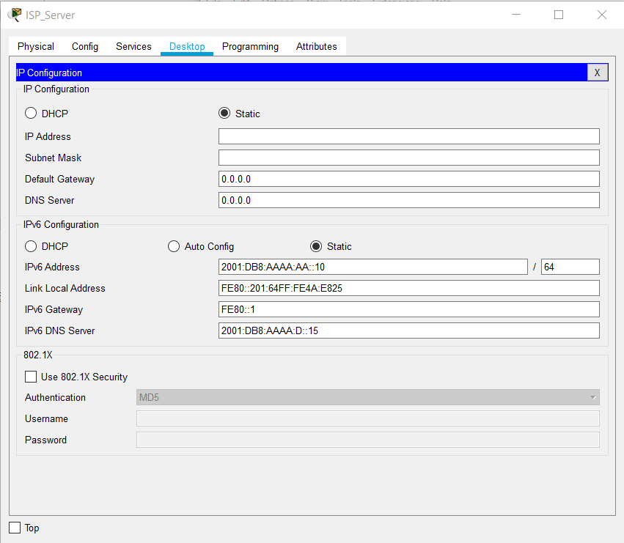

Web Server

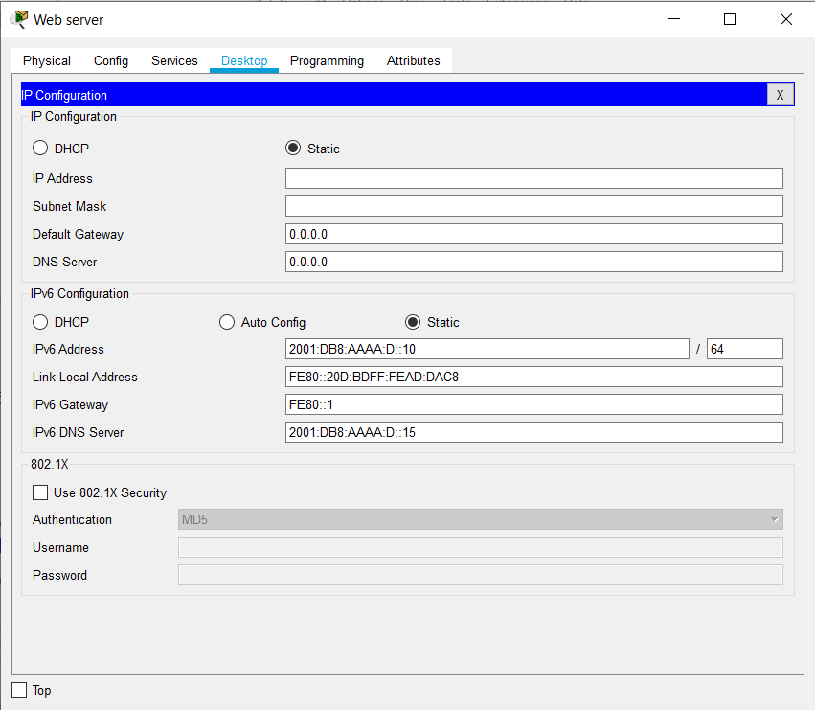

File Server

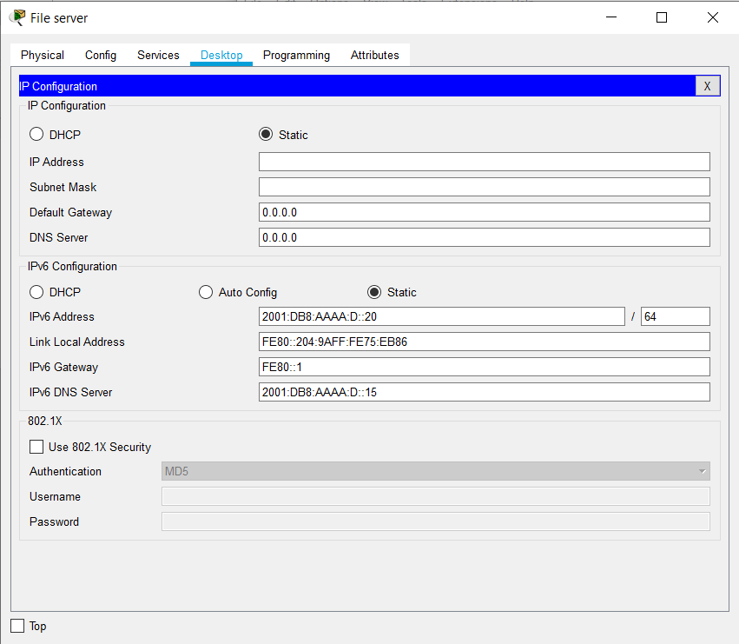

DNS Server

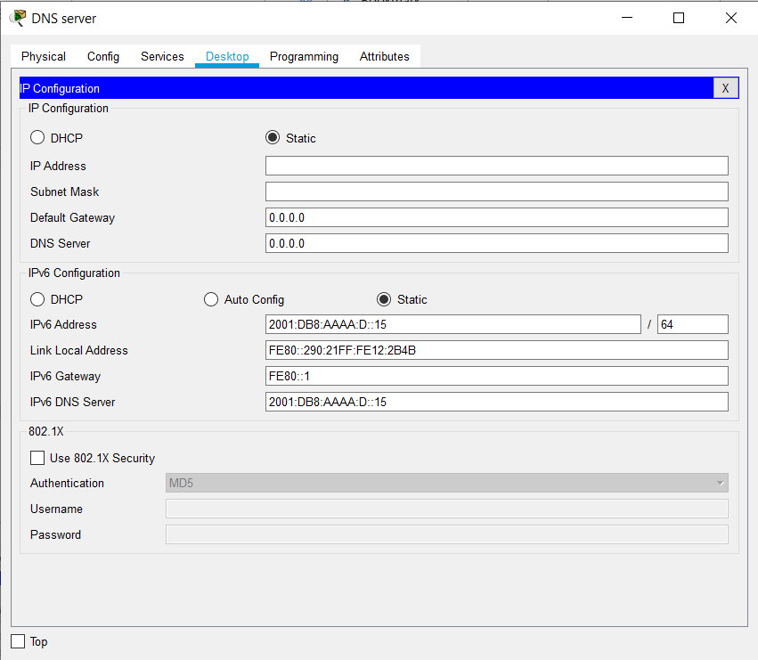

DNS Services -DNS

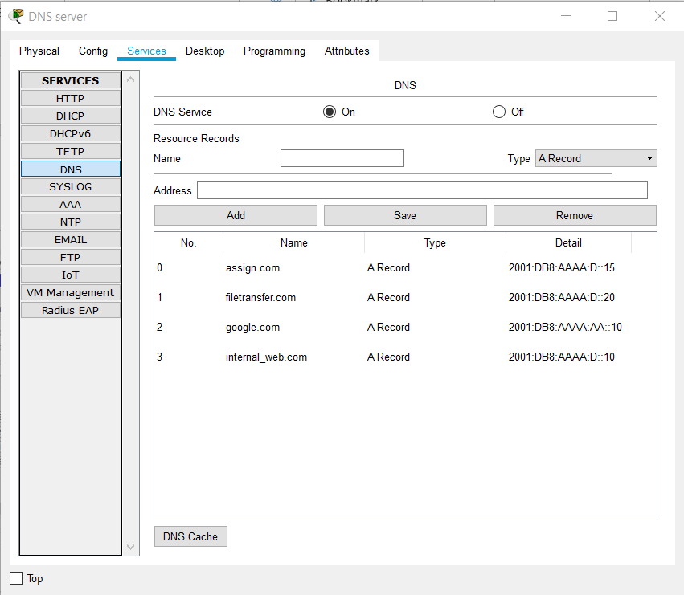

**Example Output**

Sys admin 2 Ping Central admin 1

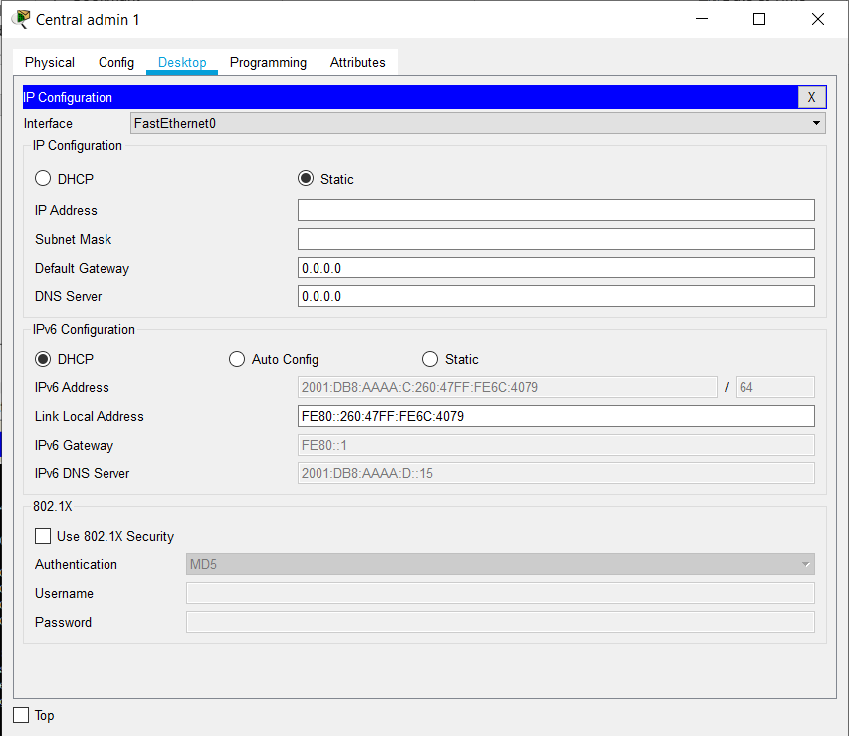

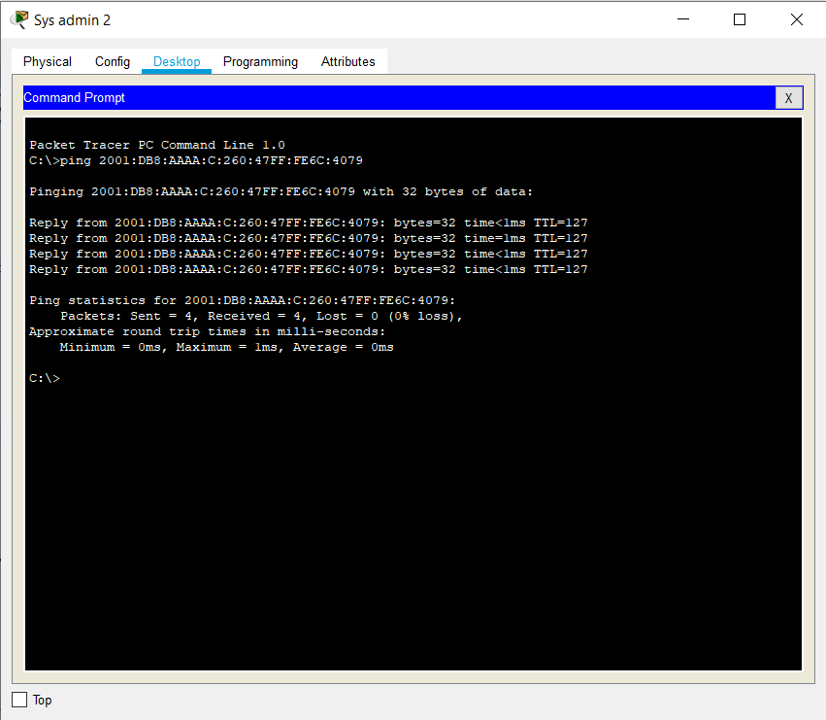

Lab3_5 open ISP_Server website (google.com)

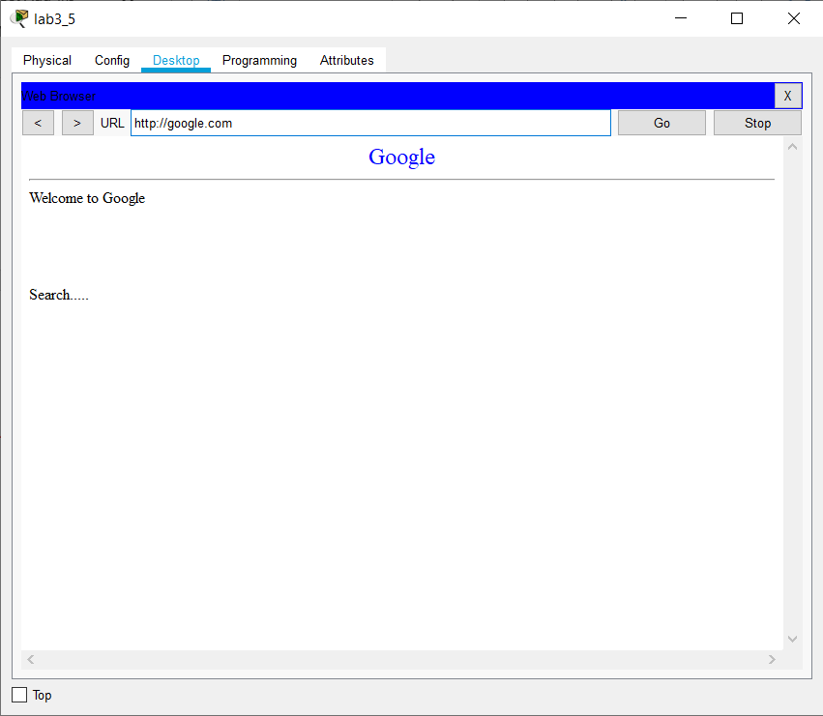

Edit and save file

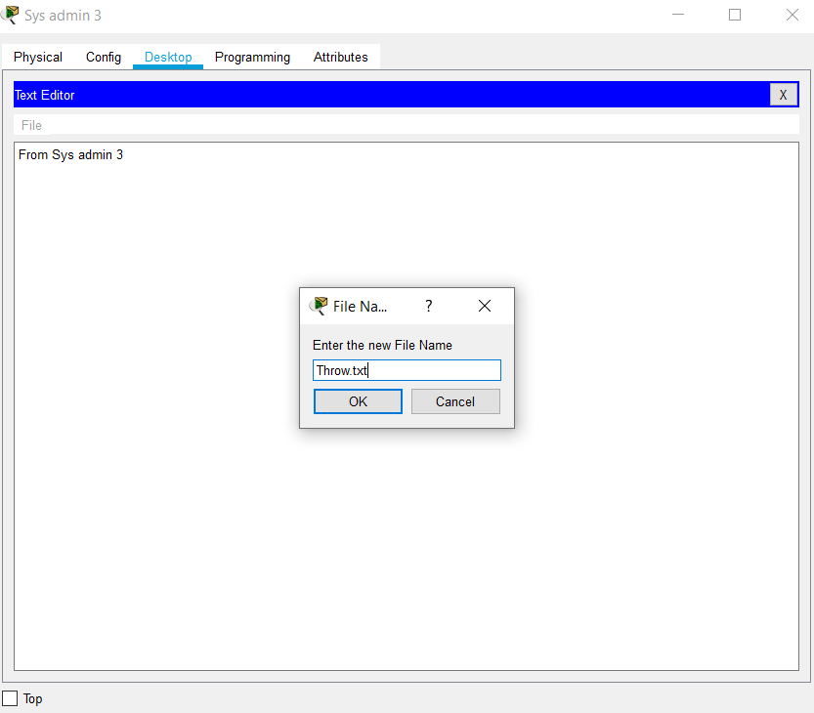

Put file (Throw.txt) to the server

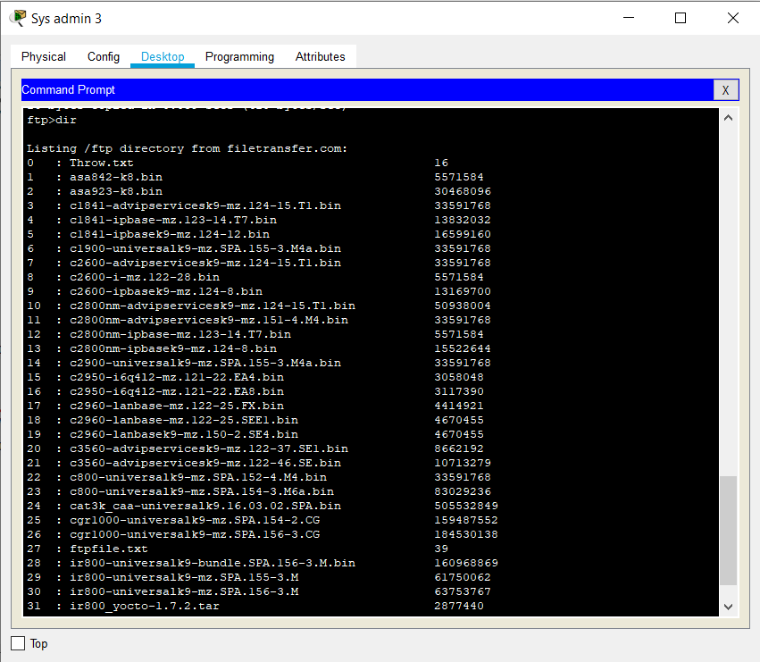

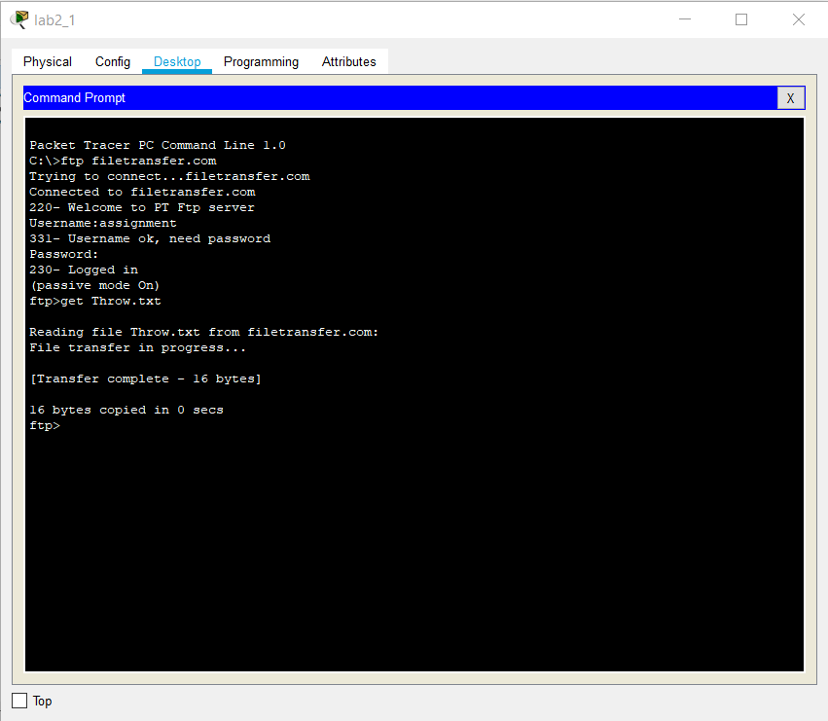Get from lab2_1

